11th June 2026

Sharding
Step1:
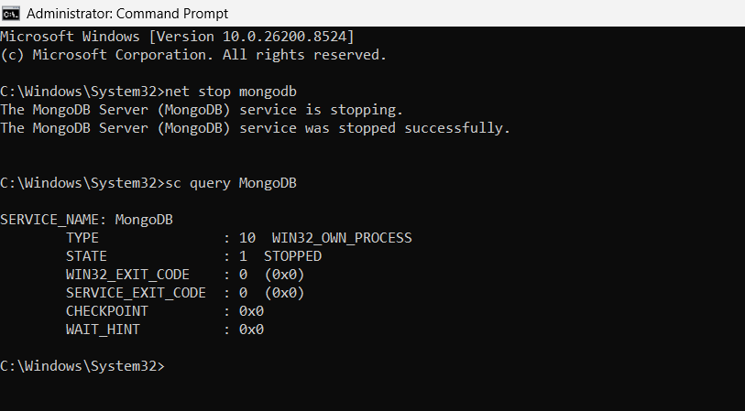

Step2:
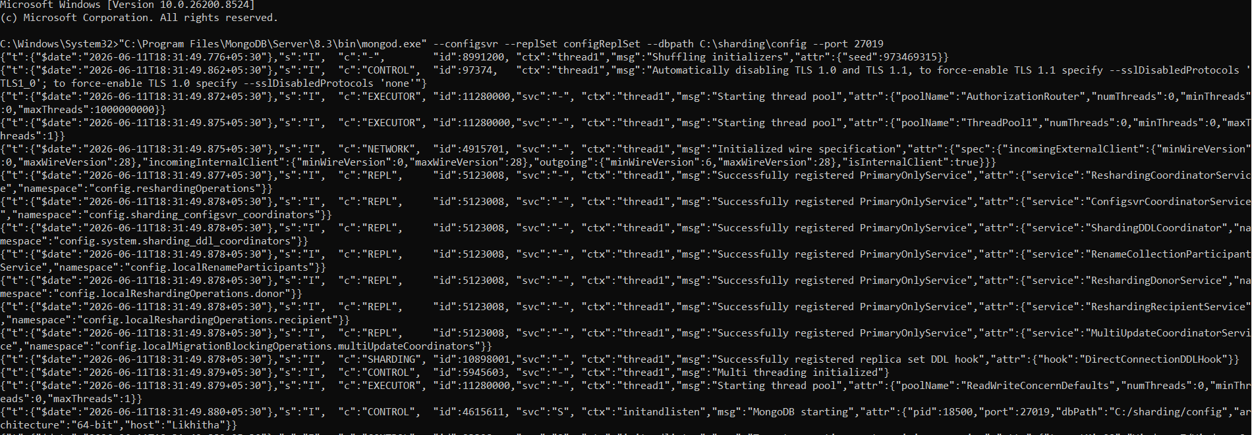

rs.initiate({
_id: "configReplSet",
configsvr: true,
members: [
{ _id: 0, host: "localhost:27019" }
]
})
{
ok: 1,
'$clusterTime': {
clusterTime: Timestamp({ t: 1781182974, i: 1 }),
signature: {
hash: Binary.createFromBase64('AAAAAAAAAAAAAAAAAAAAAAAAAAA=', 0),
keyId: Long('0')
}
},
operationTime: Timestamp({ t: 1781182974, i: 1 })
}
rs.status()
{
lastDurableWallTime: 2026-06-11T13:03:04.807Z,
lastWrittenWallTime: 2026-06-11T13:03:04.807Z
},
lastStableRecoveryTimestamp: Timestamp({ t: 1781182974, i: 1 }),
electionCandidateMetrics: {
lastElectionReason: 'electionTimeout',
lastElectionDate: 2026-06-11T13:02:54.201Z,
electionTerm: Long('1'),
lastCommittedOpTimeAtElection: { ts: Timestamp({ t: 1781182974, i: 1 }), t: Long('-1') },
lastSeenWrittenOpTimeAtElection: { ts: Timestamp({ t: 1781182974, i: 1 }), t: Long('-1') },
lastSeenOpTimeAtElection: { ts: Timestamp({ t: 1781182974, i: 1 }), t: Long('-1') },
numVotesNeeded: 1,
priorityAtElection: 1,
electionTimeoutMillis: Long('10000'),
newTermStartDate: 2026-06-11T13:02:54.263Z,
wMajorityWriteAvailabilityDate: 2026-06-11T13:02:54.718Z
},
members: [
{
_id: 0,
name: 'localhost:27019',
health: 1,
state: 1,
stateStr: 'PRIMARY',
uptime: 76,
optime: { ts: Timestamp({ t: 1781182984, i: 1 }), t: Long('1') },
optimeDate: 2026-06-11T13:03:04.000Z,
optimeWritten: { ts: Timestamp({ t: 1781182984, i: 1 }), t: Long('1') },
optimeWrittenDate: 2026-06-11T13:03:04.000Z,
lastAppliedWallTime: 2026-06-11T13:03:04.807Z,
lastDurableWallTime: 2026-06-11T13:03:04.807Z,
lastWrittenWallTime: 2026-06-11T13:03:04.807Z,
syncSourceHost: '',
syncSourceId: -1,
infoMessage: 'Could not find member to sync from',
electionTime: Timestamp({ t: 1781182974, i: 2 }),
electionDate: 2026-06-11T13:02:54.000Z,
configVersion: 1,
configTerm: 1,
self: true,
lastHeartbeatMessage: ''
}
],
ok: 1,
'$clusterTime': {
clusterTime: Timestamp({ t: 1781182984, i: 1 }),
signature: {
hash: Binary.createFromBase64('AAAAAAAAAAAAAAAAAAAAAAAAAAA=', 0),
keyId: Long('0')
}
},
operationTime: Timestamp({ t: 1781182984, i: 1 })
}

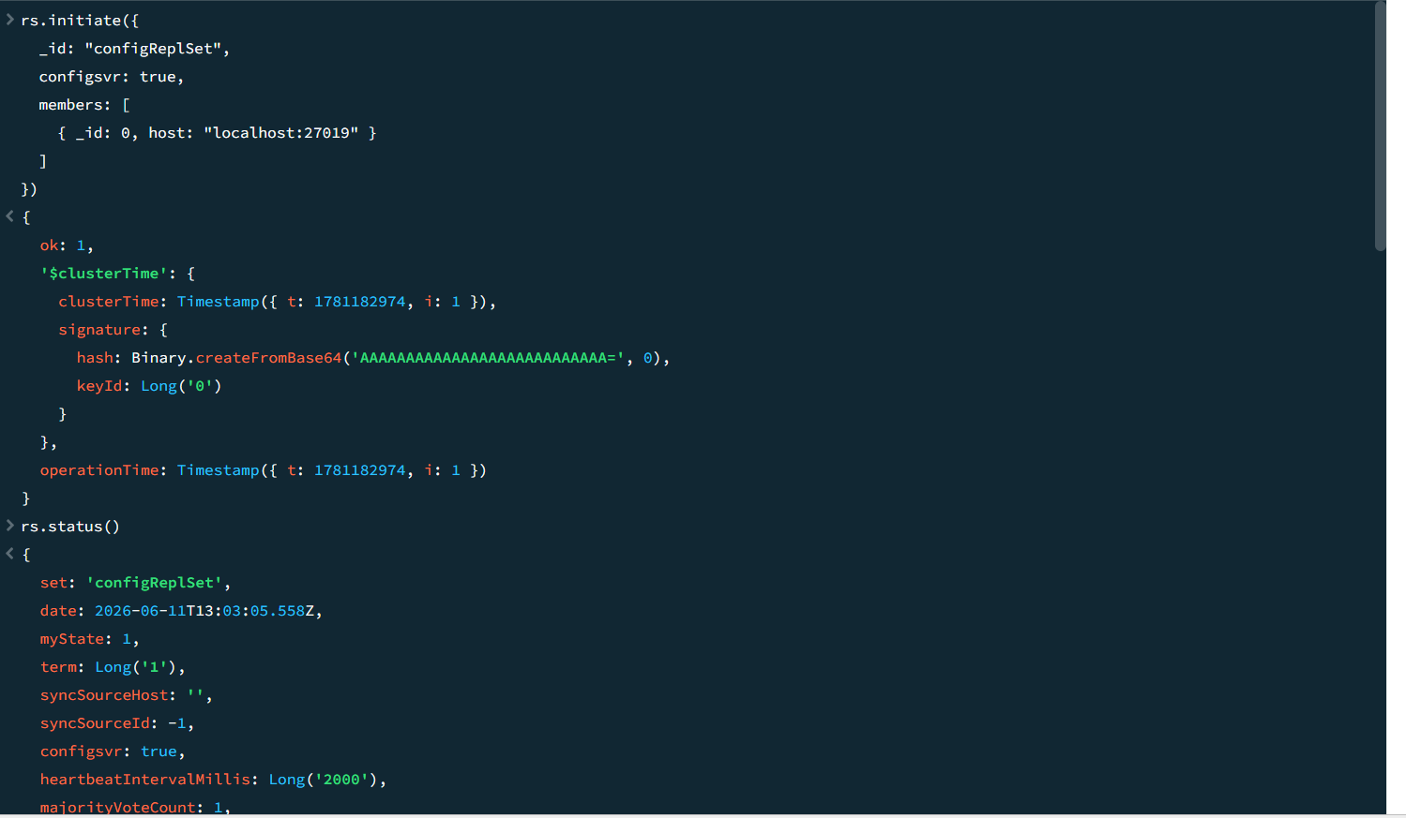
Step3:
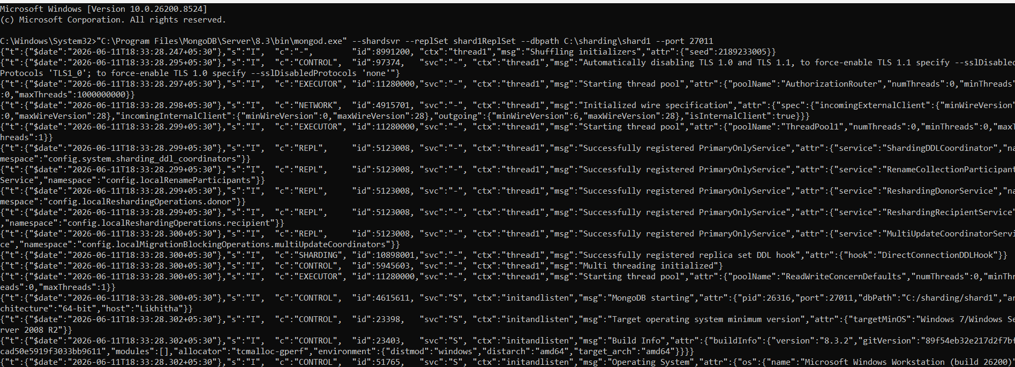

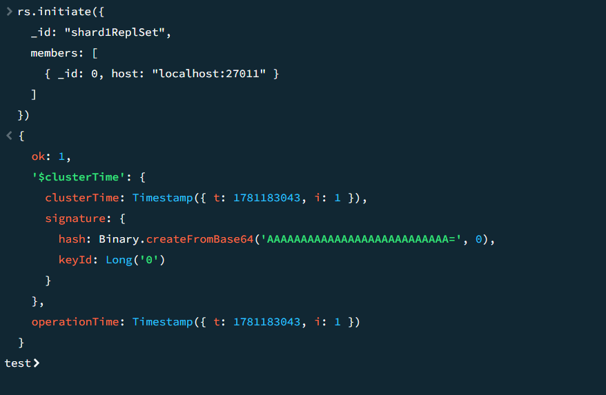

Step 4:

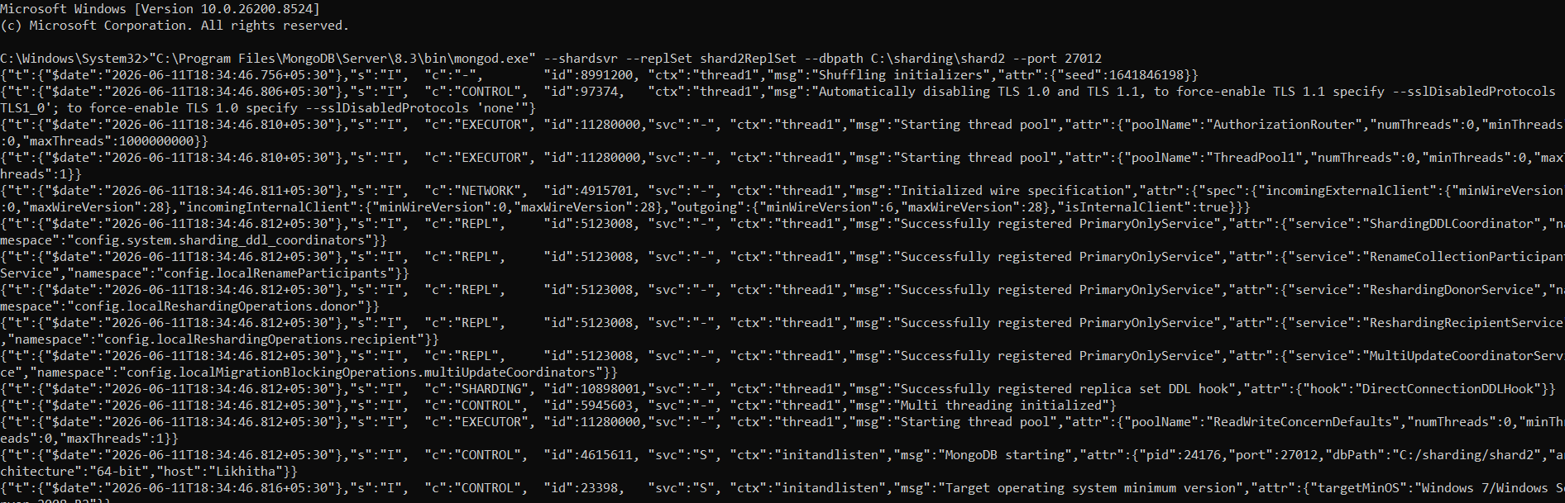

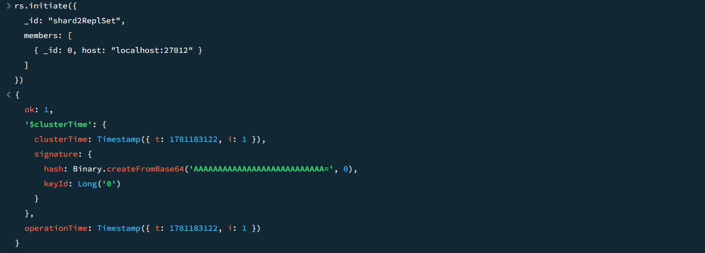

Step5:
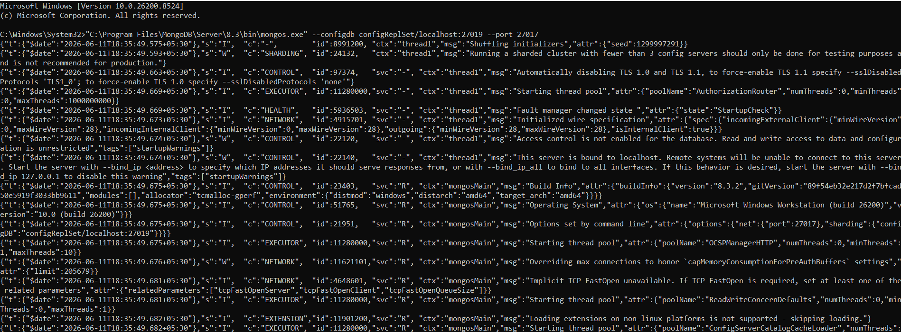
sh.addShard("shard1ReplSet/localhost:27011")
{
shardAdded: 'shard1ReplSet',
ok: 1,
'$clusterTime': {
clusterTime: Timestamp({ t: 1781183202, i: 40 }),
signature: {
hash: Binary.createFromBase64('AAAAAAAAAAAAAAAAAAAAAAAAAAA=', 0),
keyId: Long('0')
}
},
operationTime: Timestamp({ t: 1781183202, i: 40 })
}
sh.addShard("shard2ReplSet/localhost:27012")
{
shardAdded: 'shard2ReplSet',
ok: 1,
'$clusterTime': {
clusterTime: Timestamp({ t: 1781183212, i: 8 }),
signature: {
hash: Binary.createFromBase64('AAAAAAAAAAAAAAAAAAAAAAAAAAA=', 0),
keyId: Long('0')
}
},
operationTime: Timestamp({ t: 1781183212, i: 8 })
}
sh.status()
shardingVersion
{
_id: ObjectId('6a2ab1fe92834172c53dd51c'),
clusterId: ObjectId('6a2ab1fe92834172c53dd51b')
}

shards
[
{
_id: 'shard1ReplSet',
host: 'shard1ReplSet/localhost:27011',
topologyTime: Timestamp({ t: 1781183202, i: 14 }),
replSetConfigVersion: -1
},
{
_id: 'shard2ReplSet',
host: 'shard2ReplSet/localhost:27012',
topologyTime: Timestamp({ t: 1781183211, i: 74 }),
replSetConfigVersion: -1
}
]

active mongoses
[
{
'8.3.2': 1
}
]

autosplit
{
'Currently enabled': 'yes'
}

balancer
{
'Currently enabled': 'yes',
'Currently running': 'no',
'Failed balancer rounds in last 5 attempts': 0,
'Migration Results for the last 24 hours': 'No recent migrations'
}

shardedDataDistribution
[
{
ns: 'config.system.sessions',
shards: [
{
shardName: 'shard1ReplSet',
numOrphanedDocs: 0,
numOwnedDocuments: 12,
ownedSizeBytes: 1188,
orphanedSizeBytes: 0
}
]
}
]

databases
[
{
database: {
_id: 'config',
primary: 'config',
partitioned: true
},
collections: {
'config.system.sessions': {
shardKey: {
_id: 1
},
unique: false,
balancing: true,
allowMigrations: true,
chunkMetadata: [
{
shard: 'shard1ReplSet',
nChunks: 1
}
],
chunks: [
{
min: {
_id: MinKey()
},
max: {
_id: MaxKey()
},
'on shard': 'shard1ReplSet',
'last modified': Timestamp({ t: 1, i: 0 })
}
],
tags: []
}
}
}
]
sh.enableSharding("eCommerceDB")
{
ok: 1,
'$clusterTime': {
clusterTime: Timestamp({ t: 1781183231, i: 8 }),
signature: {
hash: Binary.createFromBase64('AAAAAAAAAAAAAAAAAAAAAAAAAAA=', 0),
keyId: Long('0')
}
},
operationTime: Timestamp({ t: 1781183231, i: 8 })
}
sh.shardCollection(
"eCommerceDB.orders",
{ customer_id: "hashed" }
)
{
collectionsharded: 'eCommerceDB.orders',
ok: 1,
'$clusterTime': {
clusterTime: Timestamp({ t: 1781183240, i: 19 }),
signature: {
hash: Binary.createFromBase64('AAAAAAAAAAAAAAAAAAAAAAAAAAA=', 0),
keyId: Long('0')
}
},
operationTime: Timestamp({ t: 1781183240, i: 18 })
}
use eCommerceDB
for(let i=0;i<1000;i++){
db.orders.insertOne({
customer_id:"cust_"+i,
amount:Math.random()*100
})
}
switched to db eCommerceDB
use eCommerceDB
for(let i=0;i<1000;i++){
db.orders.insertOne({
customer_id:"cust_"+i,
amount:Math.random()*100
})
}
already on db eCommerceDB
sh.status()
shardingVersion
{
_id: ObjectId('6a2ab1fe92834172c53dd51c'),
clusterId: ObjectId('6a2ab1fe92834172c53dd51b')
}

shards
[
{
_id: 'shard1ReplSet',
host: 'shard1ReplSet/localhost:27011',
topologyTime: Timestamp({ t: 1781183202, i: 14 }),
replSetConfigVersion: -1
},
{
_id: 'shard2ReplSet',
host: 'shard2ReplSet/localhost:27012',
topologyTime: Timestamp({ t: 1781183211, i: 74 }),
replSetConfigVersion: -1
}
]

active mongoses
[
{
'8.3.2': 1
}
]

autosplit
{
'Currently enabled': 'yes'
}

balancer
{
'Currently enabled': 'yes',
'Currently running': 'no',
'Failed balancer rounds in last 5 attempts': 0,
'Migration Results for the last 24 hours': 'No recent migrations'
}

shardedDataDistribution
[
{
ns: 'eCommerceDB.orders',
shards: [
{
shardName: 'shard2ReplSet',
numOrphanedDocs: 0,
numOwnedDocuments: 0,
ownedSizeBytes: 0,
orphanedSizeBytes: 0
},
{
shardName: 'shard1ReplSet',
numOrphanedDocs: 0,
numOwnedDocuments: 0,
ownedSizeBytes: 0,
orphanedSizeBytes: 0
}
]
},
{
ns: 'config.system.sessions',
shards: [
{
shardName: 'shard1ReplSet',
numOrphanedDocs: 0,
numOwnedDocuments: 12,
ownedSizeBytes: 1188,
orphanedSizeBytes: 0
}
]
}
]

databases
[
},
'on shard': 'shard1ReplSet',
'last modified': Timestamp({ t: 1, i: 0 })
}
],
tags: []
}
}
},
{
database: {
_id: 'eCommerceDB',
primary: 'shard2ReplSet',
version: {
uuid: UUID('503b6c8e-1771-41d9-b550-eb4b397f1cc8'),
timestamp: Timestamp({ t: 1781183230, i: 10 }),
lastMod: 1
}
},
collections: {
'eCommerceDB.orders': {
shardKey: {
customer_id: 'hashed'
},
unique: false,
balancing: true,
allowMigrations: true,
chunkMetadata: [
{
shard: 'shard1ReplSet',
nChunks: 1
},
{
shard: 'shard2ReplSet',
nChunks: 1
}
],
chunks: [
{
min: {
customer_id: MinKey()
},
max: {
customer_id: 0
},
'on shard': 'shard2ReplSet',
'last modified': Timestamp({ t: 1, i: 0 })
},
{
min: {
customer_id: 0
},
max: {
customer_id: MaxKey()
},
'on shard': 'shard1ReplSet',
'last modified': Timestamp({ t: 1, i: 1 })
}
],
tags: []
}
}
}
]
db.orders.getShardDistribution()
Shard shard1ReplSet at shard1ReplSet/localhost:27011
{
data: '0B',
docs: 0,
chunks: 1,
'estimated data per chunk': '0B',
'estimated docs per chunk': 0
}

Shard shard2ReplSet at shard2ReplSet/localhost:27012
{
data: '0B',
docs: 0,
chunks: 1,
'estimated data per chunk': '0B',
'estimated docs per chunk': 0
}

Totals
{
data: '0B',
docs: 0,
chunks: 2,
'Shard shard1ReplSet': [
'0 % data',
'0 % docs in cluster',
'0B avg obj size on shard'
],
'Shard shard2ReplSet': [
'0 % data',
'0 % docs in cluster',
'0B avg obj size on shard'
]
}
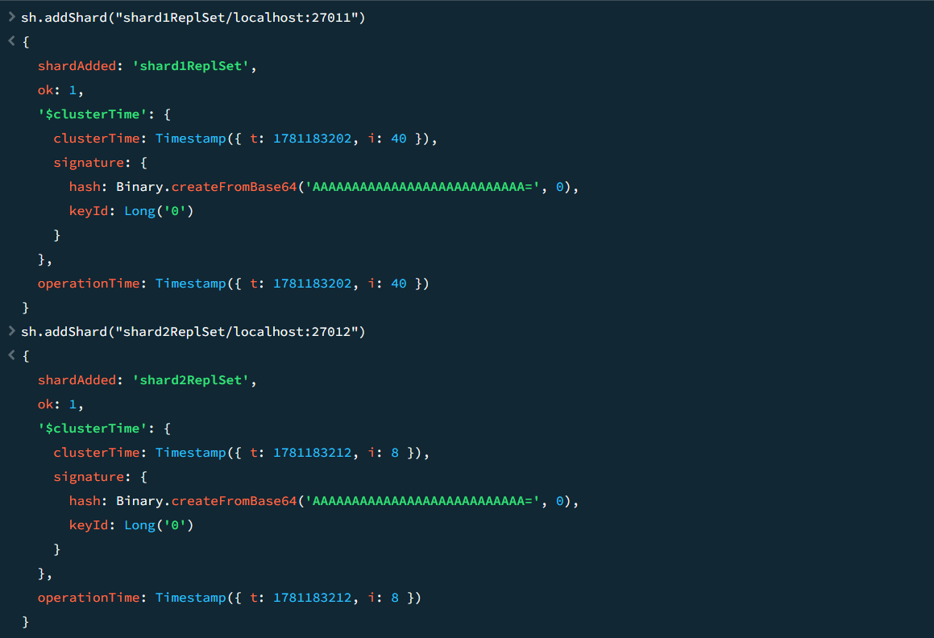

Step 6:
